Instructions on joining trap.nz and on joining a Pest Free Upper Hutt project in trap.nz

Step 1: go to the trap.nz page and click Register Now

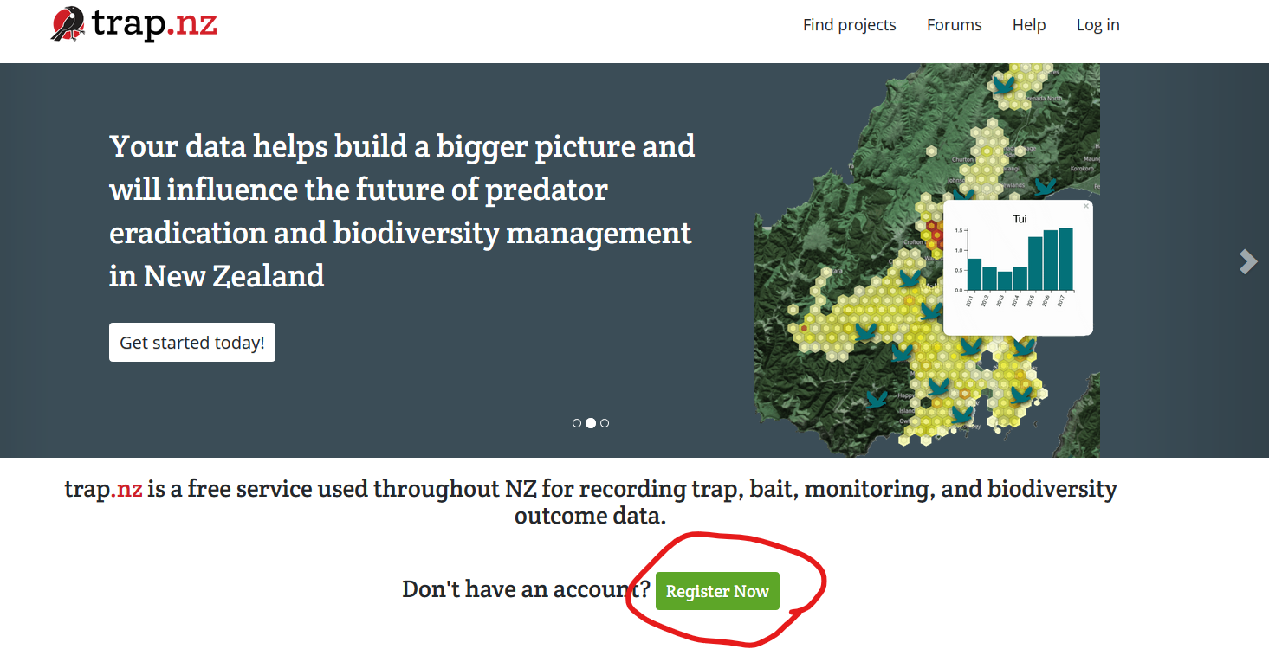
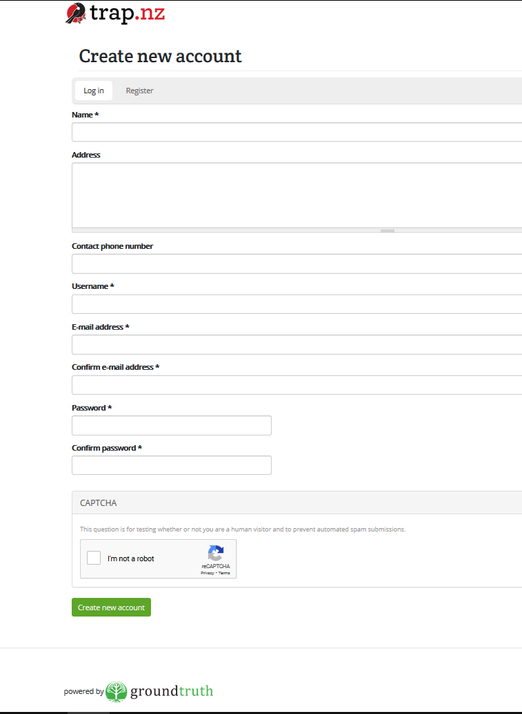
Step 2: fill in the Create New Account page and click the
“Create new account” button at the bottom of the page.

You will then get a message telling you that a validation email has been sent to your address.

Step 3: Your validation email includes a website link. Click on this link and it will verify your account and log you into the trap.nz site.

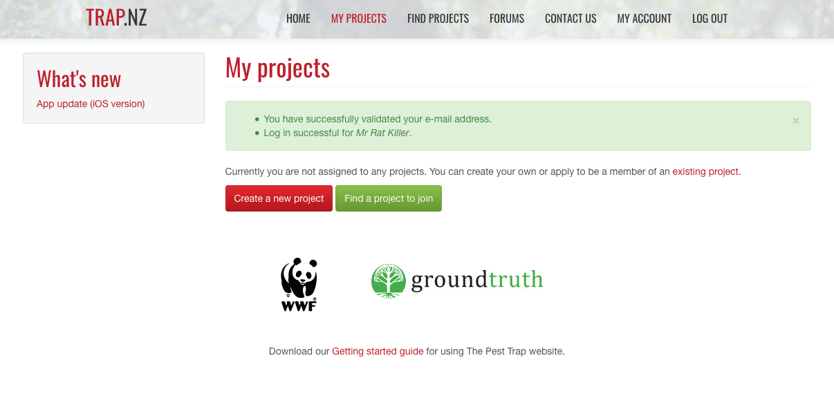

Step 4: Now you need to join a project.
Click the green button that says “Find a project to join”.
Type “Upper Hutt” into the search box and click “Apply”.

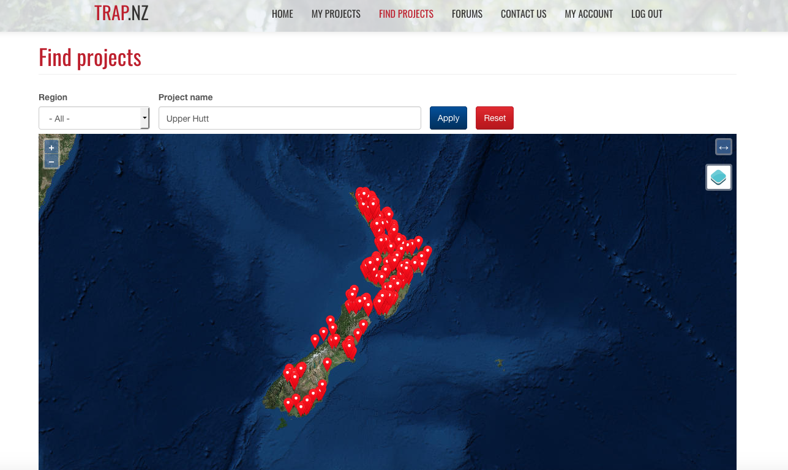

Step 5: A new map of NZ broken into regions will then be displayed. Under the map will be a list of the projects in Upper Hutt. Click on the one that includes your suburb name.
You will then see a map covering the project area. Click on “Request Membership”.

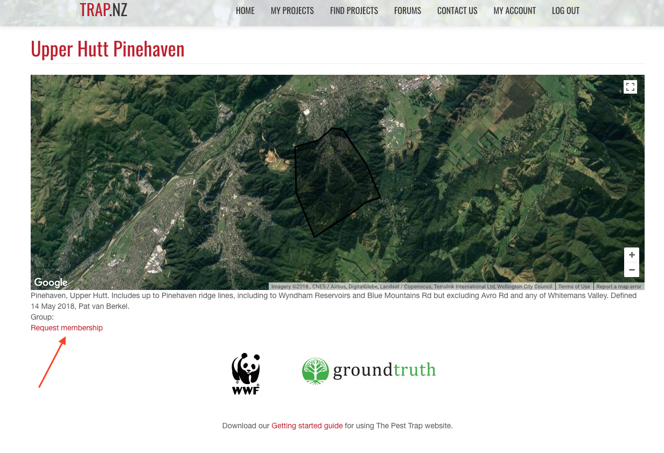

Step 6: The screen shown below will pop up. Please put your name and street in the message box. This message will go to your local Pest Free Upper Hutt coordinator.
Click “Join”. Your coordinator will then be notified by email.

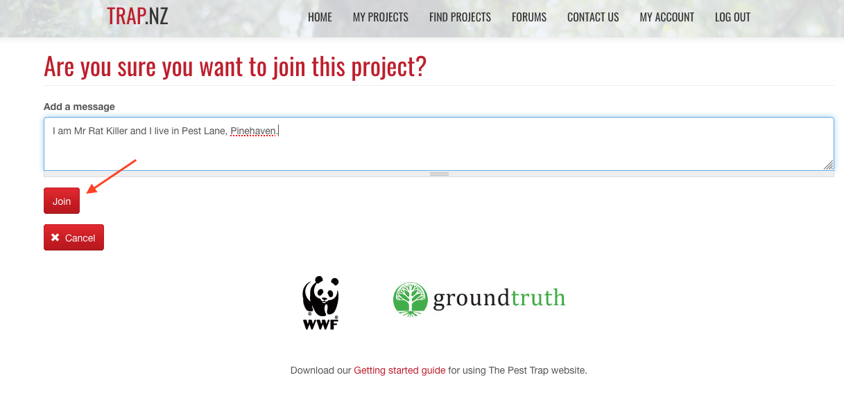

Once your local coordinator has accepted your application, you will receive an email telling you that your membership request has been approved and that you are now a member of a project. In the email, the name of your project will be in blue as a website link. Don’t use this link.

The email will also refer to the Backyard Trapper interface. We recommend you do NOT use the backyard trapper interface. Instead...

Step 7: Open your web browser and go to trap.nz. The home page will open. Click “Log in” (at the top right). Type in your user name and password and click “Log in”. You will be taken to your own home page, with your local project highlighted.

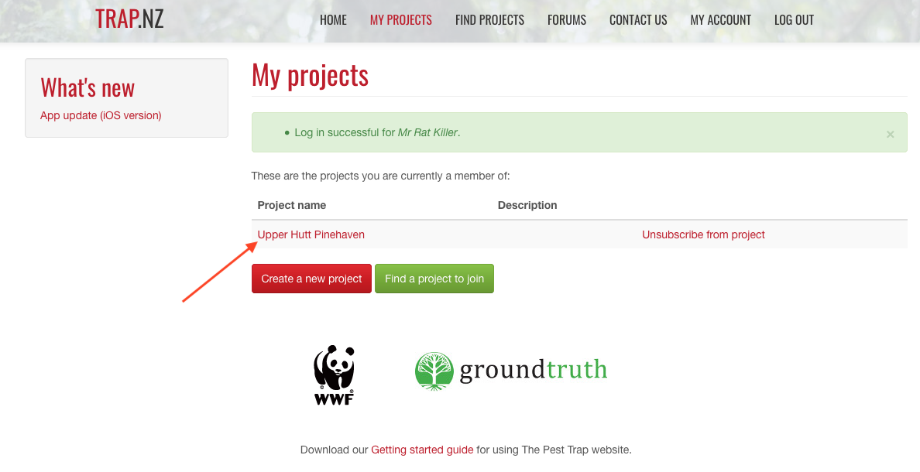

Step 8: Click on the project name. You will now see a map showing your project area, and a summary of kill data for the project.

Forever more: Follow Steps 7 and 8 each time you want to go into your project.

Registering traps and recording catches
Near the top of your home page is a menu bar that includes the option “Traps”. Use this to set up one or more traps at your property, and to record catches.

To set up a new trap on the website click “Traps” then “Add a new trap”, and fill in the form. Once you have saved this form, the new trap will appear on the project map when you log in. Please ask your coordinator for a “Trap number/code”. These follow a sequence for the project as a whole to ensure they are unique and link to a specific project.

To add trap catch data, click “Traps”. You will see a list of your trap(s) under the project map. Select the trap you want to record data for. A new map will show with the trap in the centre. To the right of the map is a red button that says “Add a new trap record”. Use this to fill in your trap data.
You can also use the Trap NZ app on smartphones to record catches.

